Liver in aging

The liver appears to preserve its function relatively well with aging and has an excellent capacity to regenerate either after partial hepatectomy or transplantation {Anantharaju2002}.

Apart from the underlying disease processes, oftentimes it is physiological aging that determines the pharmacokinetics of the drugs. Physiologic changes known to play a role in the pharmacokinetics of a drug in the elderly include: decline in total body size, total body water, lean body mass, kidney mass and function, liver mass, liver blood flow and function, serum albumin and increase in body fat stores. {Anantharaju2002} -> [50,51]

Aging is characterized by normal progressive decline in functions that, cumulatively, diminish a cell’s, organ’s or organism’s capacity to respond to intrinsic or extrinsic stimuli. Several age-related changes have been documented for the liver, including

* a decline in liver volume
* an increase in the hepatic dense body compartment (lipofuscin)
* moderate declines in the Phase I metabolism of certain drugs
* shifts in the expression of a variety of proteins
* diminished hepatobiliary functions

{Schmucker2005}

The percentage of deaths attributed to liver disease increases dramatically in humans beyond the age of 45 years. Recent data from California demonstrate a fourfold increase in liver disease-related mortality in both men and women between 45 and 85 years {Schmucker2005}.

Surprisingly, it is not clear to which extent age-inherent differences in microangio-architecture, cellularity, microvascular haemodynamics and nutritive tissue perfusion of the liver exist and whether they are contributing factors of age-related susceptibility of the liver {Vollmar2002}.

The liver mass and blood flow are reduced in old people. This causes reduction in the clearance of rapidly cleared drugs, but the clearance of slowly cleared drugs such as propranolol, amitryptiline, verapamil and morphine affected {Jansen2002}

For liver transplantations, biological age is more important than calendar age. Transplantations in elderly people with very poor liver function are associated with increased morbidity and limited survival {Jansen2002}.

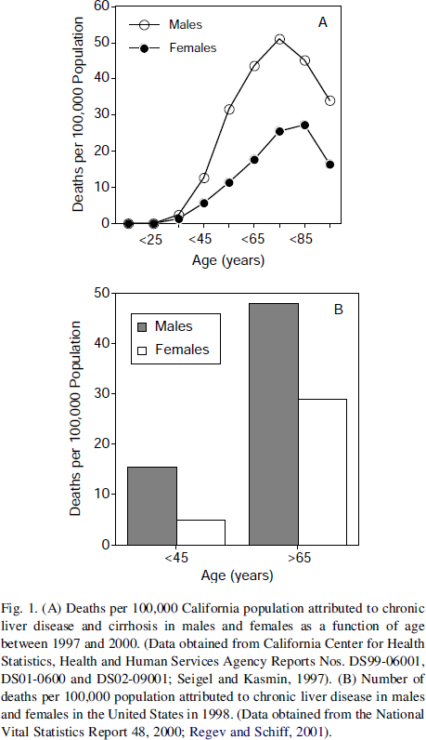

Read

{Couteur2008}

{Anantharaju2002}

{Timchenko2009}



A number of structural and microscopic changes occur as the liver ages. For example, the color of the liver changes from lighter to darker brown. Its size and blood flow decrease. However, liver function test results generally remain normal.

The ability of the liver to metabolize many substances decreases with aging. Thus, some drugs are not inactivated as quickly in older people as they are in younger people. As a result, a drug dose that would not have side effects in younger people may have dose-related side effects in older people. Thus, drug dosages often need to be decreased in older people. Also, the liver's ability to withstand stress decreases. Thus, substances that are toxic to the liver can cause more damage in older people than in younger people. Repair of damaged liver cells is also slower in older people.

The production and flow of bile decrease with aging. As a result, gallstones are more likely to form.

* reduction in liver mass
* changes in enzyme expression and activity
* reduction in blood flow
* development of shunts in cirrhosis
* changes in protein binding
* altered delivery of the phase I pathway co-substrate, oxygen
* altered transport of drugs across the hepatocyte cell membrane

# Morphological & structural changes

* reduction in number of hepatocytes
* reduction in liver size/volume
  + up to ⅓ to ½ reduction between the 3rd - 10th decade
  + < 60 years - process appears slower
  + > 60 years process is more rapid
  + female > male (in non-invasive cross sectional studies)
* increase lifespan of hepatocytes
* increase nuclei size & polyploidy
* increase mitochondrial volume
* increase intracellular protein
* increase inter-hepatocyte space & collagen
* increase lipofuscin deposition
* reduction intracellular proteinolysis

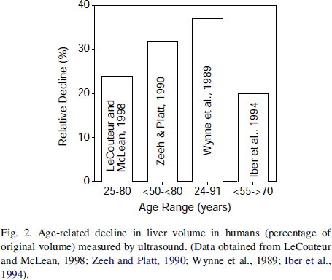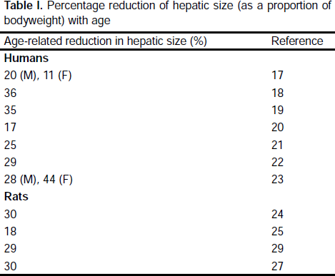{Couteur1998}

### Pseudocapillarization & Capillarization

**Pseudocapillarization** manifested by reduced sinusoidal fenestration and subendothelial collagen deposition {Jansen2002}. Pseudocapillarization differs from capillarization that occurs in cirrhosis, where it is associated with the appearance of complete basal lamina, loss of hepatocyte microvilli, fibrosis and nodular regeneration {Jansen2002}

Marked ultrastructural alterations in the liver sinusoidal endothelium and space of Disse termed ‘pseudocapillarization’ are characterized by defenestration, thickening of the endothelium, and deposition of basal lamina and extracellular matrix in the space Disse. Normal fenestrated endothelial cells of the liver sinusoids act as a dynamic filter that permits exchange of fluid, solutes and particles between the sinusoidal luman and space of Disse {Cogger2003 -> Fraser1995, Wisse1996}.

Age-related changes in the liver sinusoids and space of Disse are implicated in the association between ageing and impaired clearance of drugs {LeCouteur1998} and may provide a mechanistic link between primary aging processes and age-related disease {LeCouteur2002} {Cogger2003}. 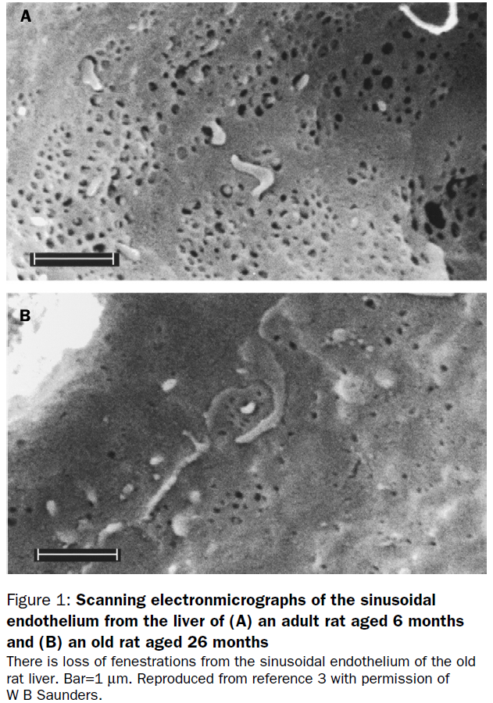

Both cirrhosis and aging are associated with marked structural changes in the sinusoidal endothelium and space of Disse that are likely to influence bulk plasma transfer into the space of Disse, and diffusion through the endothelium and space of Disse. These changes, termed **capillarization** and **pseudocapillarization** in cirrhosis and aging, respectively, impede the transfer of various substrates.

Capillarization is associated with **exclusion of albumin**, protein-bound drugs and macromolecules from the space of Disse, and the progressive **transformation of flow-limited to barrier-limited distribution of some substrates** {Couteur2005}. Structural change and subsequent dysfunction of the liver sieve warrant consideration as a significant factor in the impairment of overall substrate handling and hepatic drug metabolism in cirrhosis and aging {Couteur2005}.

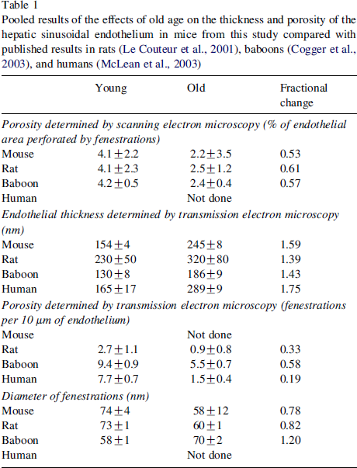

{Warren2005}

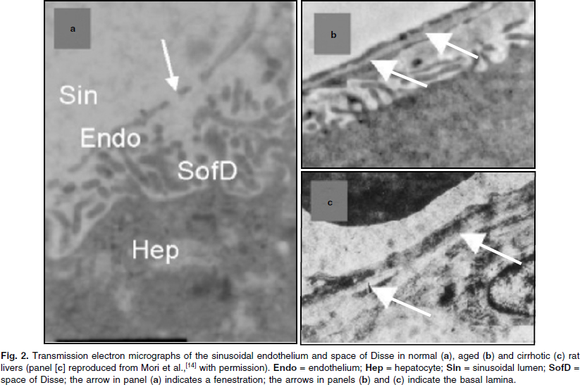

{Couteur2005}

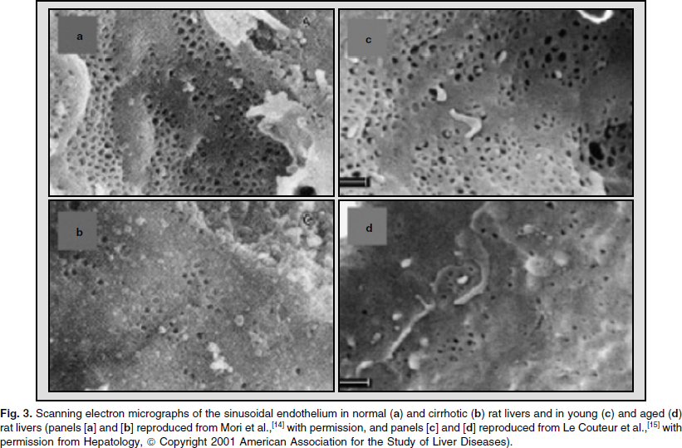

{Couteur2005}

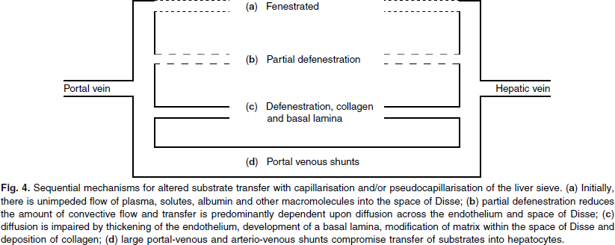

{Couteur2005}

By electronmicroscopic analysis, ageing was shown to be associated with a 50% increase in the thickness of the endothelium and a 50% reduction in the number of fenestrations in the sinusoidal endothelium (**defenestration**) {LeCouteur2002}.

Age-related changes in the hepatic sinusoid termed pseudocapillarization have been reported in rat, boboon and human and have implications for disease susceptibility in old age.

In baboons porosity declined from 4.2 to 2.4 % (~40% decrease). There was defenestration and loss of sieve plates in the the older animals, average fenestration diameter was increased slightly with age.

Hepatic pseudocapillarization is a widespread aging liver change found in several species including rats {LeCouteur2001}, humans {McLean2003} and other non-human primates {Cogger2003}

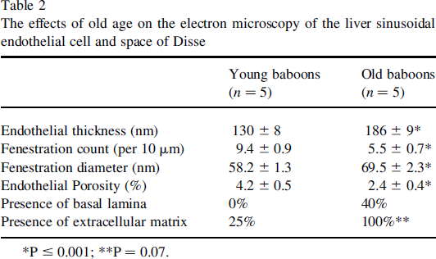

{Cogger2003}

**Material disposition in space of Disse**

Immunohistocehmical analysis showed expression of factor VIII-relatied antigen, collagen IV, and collagen I in the sinusoids of old livers. Ageing was also shown to be associated with deposition of minor amounts of collagen and formation of basement membrane within the space of Disse. These factors are seen in capillaries of non-hepatic tissues and cirhossis but not in healthy young livers {Couteur2002}.

### Cell morphology

At the light microscopic level, aging is associated with lipofuscin accumulation and an increase in multinucleate hepatocytes {Cooger2003 -> Popper1986}. With the exception of increased frequency of multinucleate cells in the older baboo group, no difference between young and old animals could be detected on the basis of hepatocyte morphology {Cogger2003}.

# Vascular changes

* reduction liver blood flow (by <= 35%) [Normal ~ 1.5 L/min]
* liver perfusion (<= 10%), i.e. blood flow per unit volume of liver tissue
* ‘The above are of uncertain significance but may be closely linked to changes in liver function with ageing

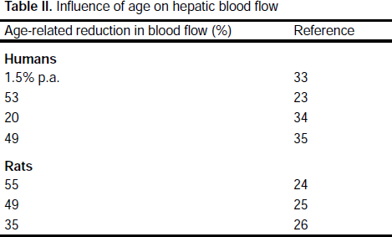{Couteur1998}

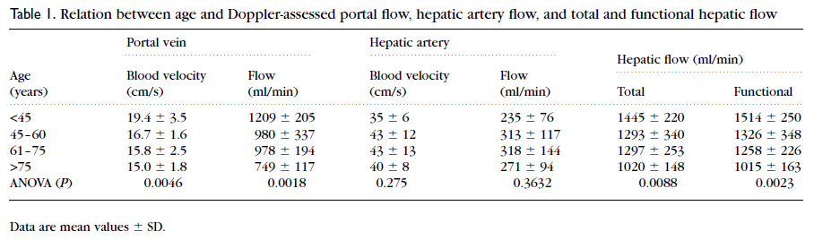

{Zoli1999}

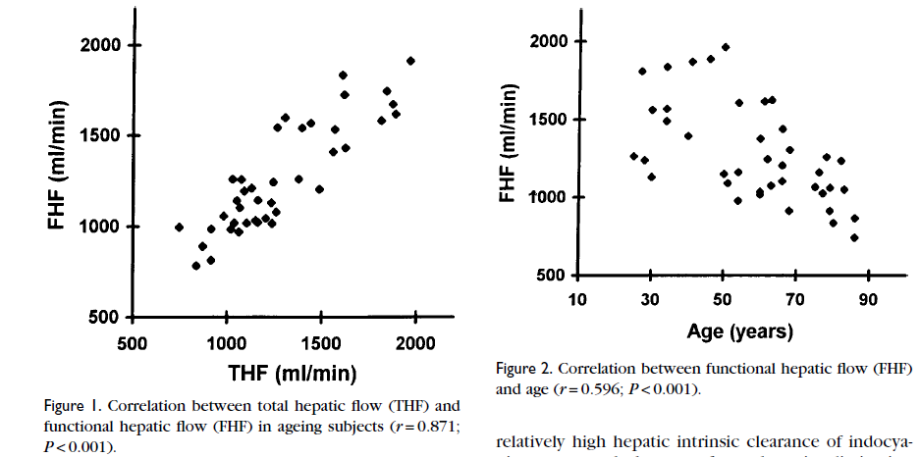

{Zoli1999}

Metabolic changes

* minimal change in blood urea/nitrogen, but **peak urea synthesis** is inversely related to age
* reduction liver cholesterol synthesis
* reduction bile acid synthesis
* increased secretion of cholesterol into bile
* reduction drug clearance (up to 50% for some drugs)
  + age alone might account for 10-30%

Ultrastructural analysis of the human liver has revealed that the integrity of mitochondria and enzymatic activity remain mostly unchanged with ageing {Anantharaju2002}.

Total capacity of the liver to metabolise many drugs declines with age in man. This decline is very variable, from drug to drug and from person to person. Reduction in liver size and blood flow with age may well offer a further major explanation for the decrease in hepatic clearance of many drugs in old age. Whilst monooxygenase enzyme activities decline in aged rats, this is not the case in humans or non-human primates, although indirect evidence suggests that a few, specific cytochrome P-450 forms may selectively decline {Woodhouse1990}

First, the blood supply to the liver reduces with age. After 25 for male and 20 for female, the blood supply to the liver is reduced 0.3 ~ 1.5% every year. The blood flow through the liver at the age of 60, compare to 20, is reduced to 40 to 50%. The blood flow brings in oxygen and nutrients, and also carries out the metabolites and toxins. When the blood supply to the liver is reduced, the liver's metabolic and detoxification ability is also reduced. This ultimately reduces the liver’s ability to repair damages from inflammation caused by virus, alcohol, or chemicals.

Second, the number of liver cells also reduces sharply after the age of 60. When we reach age 80, our liver has only 50% of the cells compared to age 40. The nucleus of the liver cells also show aging changes, such as doubling or becoming multinuclear. With aging, the liver becomes harder and the weight of the liver also reduces. The average weight of the liver for a person age 90 is only 51.8% of a person at age 30. So when we get older, there are less liver cells to carry out the important functions that keep us healthy. Plus, the phagocytic function of the Kupffer cell of the liver is also reduced to about 67%. This is an important immune function to filter the microorganisms from the nutrients gathered from the intestine. Thus, we are also more susceptible to infections when we are older.

# Aging and drugs

### Theories

Mechanism for altered hepatic substrate handling with liver disease and aging are traditionally considered to fall into

* **sick cell theory** (impaired metabolic capacity - reduced gene expression, reduced liver mass)
* **intact hepatocyte theory** (impairment in drug/substrate delivery through reduction in blood flow, development of shunts, altered protein binding or altered drug transport)

Because of these age-related changes, many drugs tend to stay in an older person's body much longer, prolonging the drug's effect and increasing the risk of side effects. Therefore, older people often need to take smaller doses of certain drugs or perhaps fewer daily doses.

Average dosage adjustments for the aged can be derived from simple equations and mean pharmacokinetic parameters from older and younger adults. However, these average dose adjustment factors neglect the large variation in the decline in organ functions among the elderly. Individual dose adjustment factors can be obtained from the drug clearance in a particular patient, where clearance/fractional bioavailability (CL/f) may be calculated from the area under the plasma concentration-time curve (AUC) of the drug in question.

Drug theraphy in the elderly may be complicated by several factors such as decline in body weight, renal function, liver mass and hepatic blood flow, making adverse drug reactions more frequent {Anantharaju2002}.

From considerations of hepatic physiology and pathology coupled with pharmacokinetic principles, it appears that altered drug elimination in liver disease may result from the following mechanisms: reduction in absolute cell mass, in cellular enzyme content and/or activity, in portal vein perfusion due to extrahepatic/intrahepatic shunting, or of portal perfusion of hepatocyte mass due to decreased portal flow or sinusoidal perfusion; increase in arterial perfusion relative to portal perfusion; preferential perfusion of the sinusoidal midzone and terminal zones by arterioles; potential for direct mixing of arterial blood within the space of Disse; reduced exchange across the endothelial lining; and impaired diffusion within the space of Disse.

In general, oxidative drug metabolism is impaired in liver disease and the degree of impairment of oxidation differs between drugs but correlates best with the degree of sinusoidal capillarisation, i.e. the degree of access of the drug from the sinusoid to the hepatocyte.

This study raises an important question: What kind of people can be taken to represent “normal” or “control” subjects in investigations of drug metabolism in humans {Sotaniemi1997}

# References

Anantharaju, Abhinandana, Axel Feller, and Antonio Chedid. "Aging liver." *Gerontology* 48.6 (2002): 343-353.

Cogger, Victoria C et al. "Hepatic sinusoidal pseudocapillarization with aging in the non-human primate." *Experimental gerontology* 38.10 (2003): 1101-1107.

Huet, Pierre‐Michel, and Jean‐Pierre Villeneuve. "Microcirculation of the aging liver: Is getting old like having cirrhosis?." *Hepatology* 42.6 (2005): 1248-1251.

Le Couteur, David G et al. "The hepatic sinusoid in aging and cirrhosis." *Clinical pharmacokinetics* 44.2 (2005): 187-200.

Ito, Yoshiya et al. "Age-related changes in the hepatic microcirculation in mice." *Experimental gerontology* 42.8 (2007): 789-797.

Jamieson, Hamish A et al. "Caloric restriction reduces age-related pseudocapillarization of the hepatic sinusoid."

*Experimental gerontology* 42.4 (2007): 374-378.

Jansen, Peter LM. "Liver disease in the elderly." *Best Practice & Research Clinical Gastroenterology* 16.1 (2002): 149-158.

Klotz, Ulrich. "Pharmacokinetics and drug metabolism in the elderly." *Drug metabolism reviews* 41.2 (2009): 67-76.

Kitani, Kenichi. "Aging and the liver: fucntional aspects." *Archives of gerontology and geriatrics* 19.2 (1994): 145-158.

Kitani, Kenichi. "Aging of the liver: facts and theories." *Archives of gerontology and geriatrics* 12.2 (1991): 133-154.

Le Couteur, D. G., Fraser, R., Cogger, V. C., & McLean, A. J. (2002). Hepatic pseudocapillarisation and atherosclerosis in ageing. *The Lancet*, *359*(9317), 1612-1615.

Le Couteur, David G et al. "Old age and the hepatic sinusoid." *The Anatomical Record* 291.6 (2008): 672-683.

McLean, Allan J et al. "Age‐related pseudocapillarization of the human liver." *The Journal of pathology* 200.1 (2003): 112-117.

McLean, Allan J, and Denis J Morgan. "Clinical pharmacokinetics in patients with liver disease." *Clinical pharmacokinetics* 21.1 (1991): 42-69.

Morgan, Denis J, and Allan J McLean. "Clinical pharmacokinetic and pharmacodynamic considerations in patients with liver disease." *Clinical pharmacokinetics* 29.5 (1995): 370-391.

Schmucker, Douglas L. "Age-related changes in liver structure and function: implications for disease?." *Experimental gerontology* 40.8 (2005): 650-659.

Schmucker, Douglas L, Jill S Mooney, and Albert L Jones. "Stereological analysis of hepatic fine structure in the Fischer 344 rat. Influence of sublobular location and animal age." *The Journal of cell biology* 78.2 (1978): 319-337.

Schmucker, Douglas L, and Howard Sachs. "Quantifying dense bodies and lipofuscin during aging: a morphologist's perspective." *Archives of gerontology and geriatrics* 34.3 (2002): 249-261.

Sotaniemi, Eero A et al. "Age and cytochrome P450-linked drug metabolism in humans: An analysis of 226 subjects with equal histopathologic conditions*." *Clinical Pharmacology & Therapeutics* 61.3 (1997): 331-339.

Timchenko, Nikolai A. "Aging and liver regeneration." *Trends in Endocrinology & Metabolism* 20.4 (2009): 171-176.

Vollmar, Brigitte et al. "In vivo quantification of ageing changes in the rat liver from early juvenile to senescent life." *Liver* 22.4 (2002): 330-341.

Wakabayashi, Hisao et al. "Evaluation of the effect of age on functioning hepatocyte mass and liver blood flow using liver scintigraphy in preoperative estimations for surgical patients: comparison with CT volumetry." *Journal of Surgical Research* 106.2 (2002): 246-253.

Warren, A., Bertolino, P., Cogger, V. C., McLean, A. J., Fraser, R., & Couteur, D. G. L. (2005). Hepatic pseudocapillarization in aged mice. *Experimental gerontology*, *40*(10), 807-812.

Warren, Alessandra et al. "Effects of old age on vascular complexity and dispersion of the hepatic sinusoidal network." *Microcirculation* 15.3 (2008): 191-202.

Woodhouse, KW, and OF James. "Hepatic drug metabolism and ageing." *British medical bulletin* 46.1 (1990): 22-35.